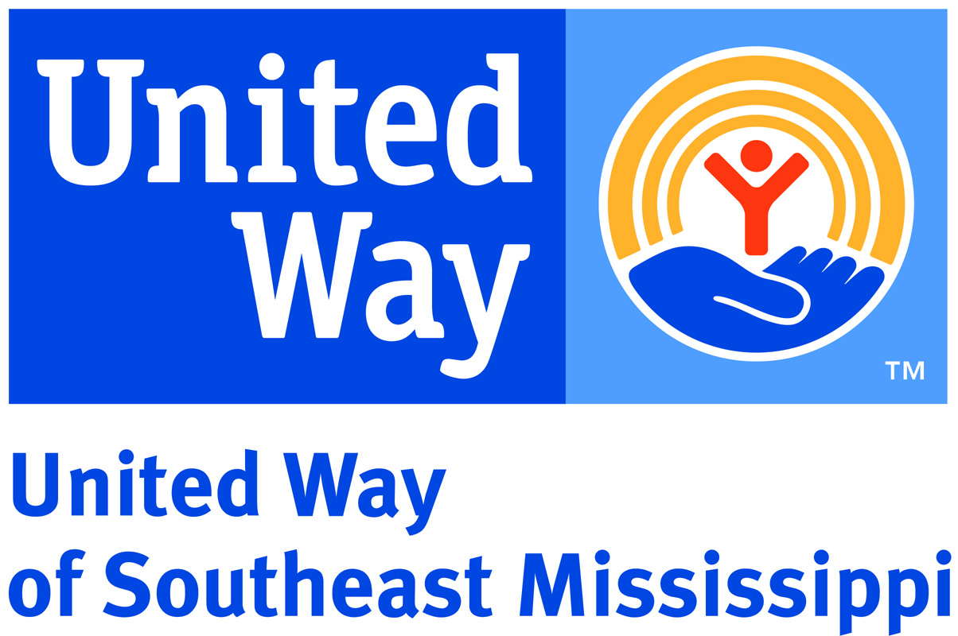

DISASTER RELIEF & RECOVERY GRANT APPLICATION

Purpose: United Way of Southeast Mississippi Disaster Relief & Recovery Grants provide supplement funding to a non-profit or not-for-profit entity serving Forrest, Lamar, Perry and Marion Counties immediately following a widespread disaster such as a hurricane, tornado, flood, pandemic or act of terrorism. Requests will be considered from organizations in pressing need of funds caused by unanticipated or non-budgeted costs for which there are no other resources or for which available resources, both in-kind and monetary, have been inadequate to meet these costs. Applicants must be actively responding to immediate human needs by providing and managing the distribution of services such as shelter, food, clothing, supplies, transportation, debris removal, mud-outs, and housing.
Procedure: It is the responsibility of the submitting organization to ensure the application is received by 5:00 p.m. CDT on Friday, June 23, 2017. Requests will be evaluated, award amounts determined and approved by the United Way of Southeast Mississippi Board of Directors. Applicants must answer questions in space provided. Requests for personnel costs will not be considered.
Required Attachments: If your organization is not currently receiving funds from United Way of Southeast Mississippi, please attach the following to your application:
- One copy of your IRS determination letter certifying your organization is a not for profit
- Most recent Board of Directors or Church officers/trustees list including professional affiliations and contact information.

Reporting Requirements:
A final report including totals of elements listed below will be due no later than three months after grant is issued
1) Dates of service provision (i.e. February 1st through 7th, 2017);
2) Number of persons/clients reached during specified time period;
3) Units of service provided (i.e. number of food boxes, prescriptions, counseling sessions, meals served, vouchers, etc.);
4) Total United Way of Southeast Mississippi Disaster Relief & Recovery Funds spent on services funded in the award;
5) Total funds from other sources spent on services provided within the scope of this grant.

Applications should be addressed to “Disaster Relief & Recovery Grant” and submitted through the following methods
Mail:
United Way of Southeast Mississippi
P.O. Box 1648
Hattiesburg, MS 39403

Hand deliver to United Way office:
210 W. Front St. Ste. 400
Hattiesburg, MS 39401

Email:
tracie@unitedwaysems.org

Contact Name
Organization Name
Address
Phone
Fax
Email

Total Grant Request: $_________________

1. Provide a brief, concise description of your program?
2. Briefly describe your organization’s need and why it is an urgent or unanticipated need for your organization.
3. What is your organization’s current capacity (i.e. number of assisting personnel, area to be served, etc) to provide the services you seek to provide through this grant?
4. Provide the cost of each of the requested program supply/organizational need, if requesting support for multiple areas, items and or supplies. Provide any additional details that would help us understand how the funds would be spent.
5. How will you determine who receives services?

Signatures:
Executive Director or Pastor | Chief Volunteer Officer
Printed Name | Printed Name
Date | Date

